Newsletter – November 22

St John’s House in November

The Hallowe’en storytelling went well with David Ambrose demonstrating what an accomplished storyteller he is. Now it’s a case of cleaning, moving the furniture back and sorting out the appropriate Christmas decorations ready for our next open day. We’ll also be fitting in an extra open day before Christmas on 10/12 when the ‘Call of the Wild’ folk group will be performing in the house.
Because of competing priorities, the craft fayre we had planned for November will now be deferred to a later date
Our next quiz in aid of St John’s will again be at the outdoor bowls club in Newbridge Fields.

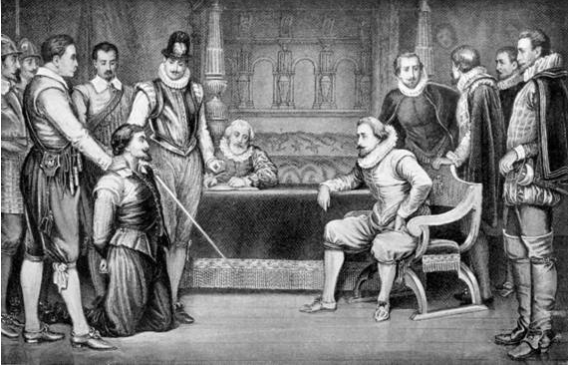

James I of England interrogates Guy Fawkes
Illustrations from English & Scottish History 1884
Picture credit:Wikimedia.

St John’s House had been standing for nearly 100 years when Guy Fawkes attempted to assassinate the King by blowing up Parliament in November 1605.

Dates for your diary

Next two open days Saturday 26th November 11am-3pm
Saturday 10th December 11am-3pm

Next two quiz dates Friday 18th November 7.30pm
Friday 16th December 7.30pm

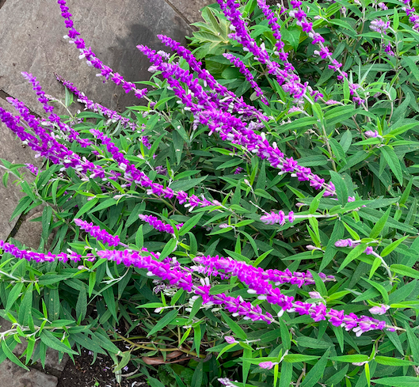
Lavender
Lavender has been used throughout history as a means of healing wounds, treating headaches, scenting clothes, hiding unpleasant smells and flavouring food. The Egyptians used lavender in the process of mummifying bodies.
It is thought to have been introduced to the UK by the Romans and the word ‘lavender’ most likely comes from the latin ‘lavare’ to wash. They used it for cooking, bathing and as insect repellant.
It was woven into crosses and hung up to ward off evil. Lavender was strewn across the floors of houses in the Middle Ages to combat the less than fragrant odours of both cooking and general life at a time when clothes were rarely laundered and bodies seldom washed. People carried posies of fresh lavender to protect themselves against the Plague. Some scientific studies have suggested that lavender may have aphrodisiac qualities and it has long been known as one of the herbs of love. Queen Elizabeth l and Queen Victoria were both great lavender enthusiasts and used lavender extensively.
These days it is found in perfumes, in essential oils used in aromatherapy and in foodstuffs such as lavender shorbread. With the increasing awareness of, and interest, in sustainability, dried lavender is often used at weddings as biodegradable, natural confetti.

Here at St John’s House we have bagged dried lavender for sale for making lavender bags – or for confetti! – and, if you don’t fancy making your own lavender bags, we have a selection for sale in our shop.
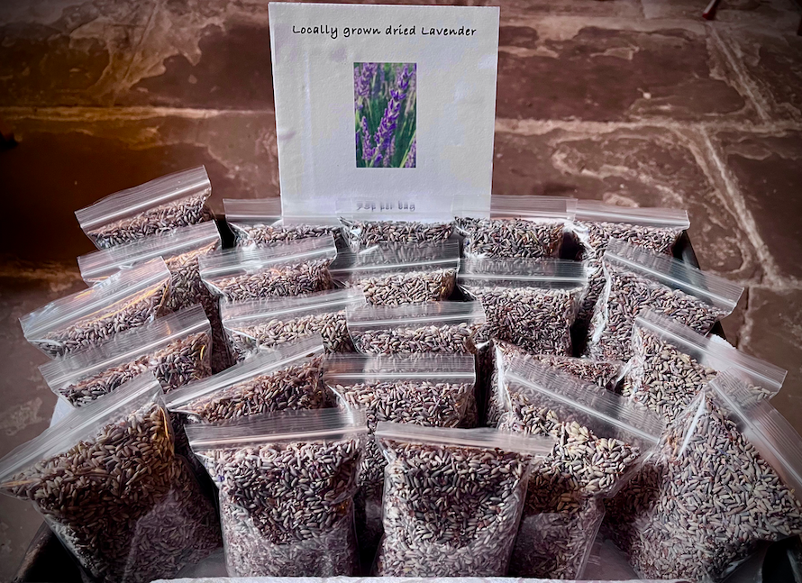
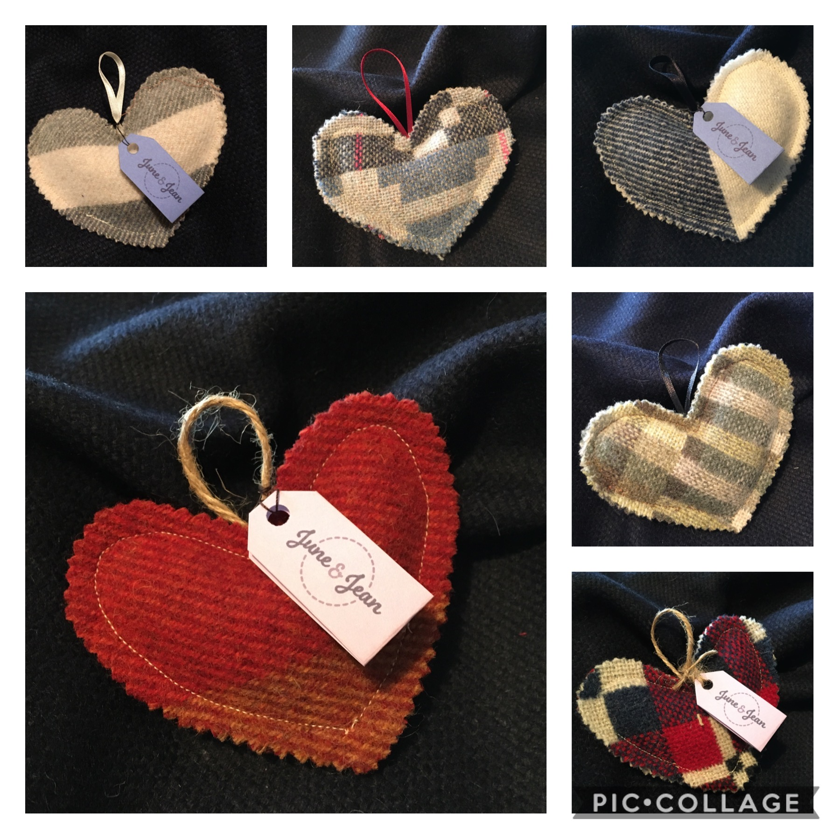

St John’s House is a charity, our charity number is 1147340
Email: saintjohns@hotmail.co.uk
Website: https://stjohns-bridgend.org.uk
Facebook: St John’s House Bridgend
Address: 22 Newcastle Hill, Bridgend, CF31 4EY
If you no longer which to receive communications from us, please let us know at the email address above

