

**Newsletter** – March 2023

**St John’s House in March**

February’s Open Days celebrating St Dwynwen and St Valentine were busy with plenty of children enjoying the various things to do in the Solar – toys, brass-rubbing, games, colouring and dressing up. We also marked

St David’s Day with a Dewi the Dragon trail for children and a riot of Welsh Flags everywhere.

Tim, our current resident artist is still encouraging visitors to contribute to the bench he’s painting and, as ever there are tea and coffee available.

The events team have booked Debra John, the actress who delivered such a memorable evening last December and David Ambrose, the renowned story teller who gave us hallowe’en stories, to come along and perform in the house later this year. Look out for the details of these and other events still in the planning stage.

March Open Days will be all about Easter, so expect Easter chicks, Easter Bunnies and lots of eggs!

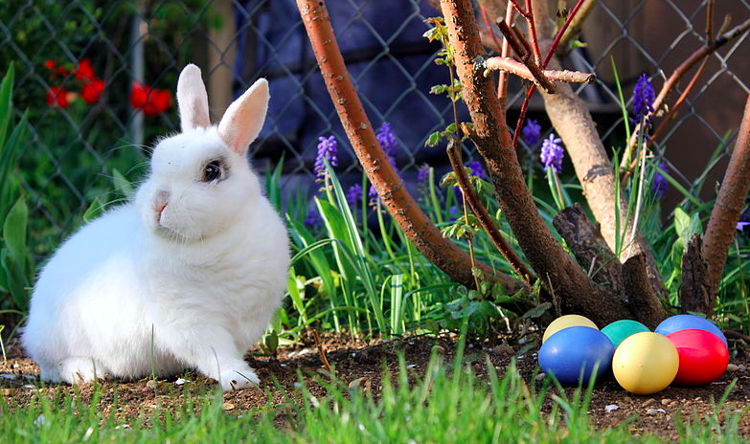

**Dates for your diary**

**Next open days** Sunday 10th March 2024 11am-3pm

Saturday 30th March 2024 11am-3pm

Sunday 14th April 2024 11am-3pm

Saturday 27th April 2024 11am-3pm

**Next two quiz dates** Friday 15th March 2024 7.30pm

Friday 19th April 2024 7.30pm

**Equinoxes and Solstices**

On March 20th this year we celebrate the spring or vernal equinox. This is the point where day and night are of equal length (equi - equal and nox - night) and is regarded as the first day of Spring. It will actually occur in 2024 at 3.06 am, if you happen to be up and about that early!

There are, as you would imagine, two equinox days a year, the other, the autumn equinox, when day and night are again equal, will be September 22nd.

The solstice is the point in the year when the sun is nearest to the earth (summer solstice) or farthest from the earth (winter solstice). The word solstice derives from the latin for *sun stands still*.

Together the equinoxes and the solstices represent the four points in the year when the seasons change in response to the movements of the sun.

There are, of course, rituals asscoiated with the spring equinox – many people greet the rising sun either as part of the celebrations at Stonhenge or quietly in the back garden with a cup of tea. There are ceremonies involving eggs as a symbol of rebirth and others where you plant seeds as a harbinger of the harvest to come.

Spring cleaning is another ancient tradition triggered by the equinox - as the strength of the sun increases it shines into the corners where the dust has gathered over the winter!

In some cultures it is regarded as th e point where new year starts and is celebrated as such with parties and new year resolutions

It will be refreshing to see the days lengthen, the garden come alive again and lambs bouncing about in the fields.

However you celebrate the equinox, why not make a resolution to come along and drink in the atmosphere of our glorious Tudor house again.

We look forward to seeing you.

St John’s House is a charity, our charity number is 1147340

Email: [saintjohns@hotmail.co.uk](mailto:saintjohns@hotmail.co.uk)

Website: <https://stjohns-bridgend.org.uk>

Facebook: St John’s House Bridgend

Address: 22 Newcastle Hill, Bridgend, CF31 4EY