Newsletter – January 2023

St John’s House in January
Happy New Year to you all. Let’s hope for a calmer, less eventful year in 2023. Once we reach Twelfth Night and the end of the twelve days of Christmas, we can take down and put away the decorations for next year.
We will take all of the greenery which we used to festoon the house to the compost heap. The Tudors very much lived according to the seasons and nothing went to waste so we follow their example.
For our January Open Day we are decorating the house to celebrate St Dwynwen with a nod to her English counterpart, St Valentine – See you there!

Our first quiz of the year in aid of St John’s will take place, as usual, at the outdoor bowls club in Newbridge Fields.

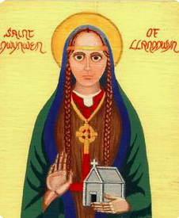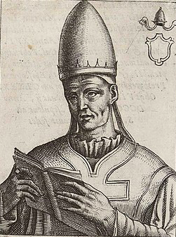
St Dwynwen

St Valentine

Dates for your diary

Next two open days Saturday 28th January 2023 11am-3pm
Saturday 25th February 2023 11am-3pm

Next two quiz dates Friday 20th January 2023 7.30pm
Friday 17th February 2023 7.30pm

St Dwynwen’s Day 25th January

St Dwynwen was one of 24 daughters of King Brychan Brychaenog of Brecon. The details of her story vary but the essence is that she was in love with a neighbouring Prince called Maelon Dafodrill but her father had already promised her in marriage to another. When the couple were told that they couldn’t marry Maelon didn’t take it well and, as a consequence of his bad behaviour, was turned into a block of ice. Dwynwen appealed to God for help and cried herself to sleep in a forest. In a dream, an Angel appeared and granted her three wishes. She used the first wish, rather generously, to thaw out Maelon, for the second she asked that God watch over all lovers and the third wish was that she should never marry. She became a nun and founded a convent on Llanddwyn Island just off the coast of Anglesey where the ruins of her church and a holy well attributed to her remain to this day.

St Valentine’s Day 14th February

St Valentine was Roman bishop, martyred on February 14th AD 269 as a consequence of having tried to convert Emperor Claudius ll to Christianity. Like St Dwynwen, details of his life and of the good deeds which earned him sainthood are sketchy and varied but his connection to declarations of love are based on the story that, having restored the sight of at least one young girl, he sent her a note, just before his execution, signed “Your Valentine”
He has always been linked with the idea of courtly love.

Whichever of the saints you may favour and, with their saint’s days being so close together, why not go for both, we will be happy to welcome you to our Tudor House which we are decorating to celebrate appropriately.

Here at St John’s House we have all sorts of handcrated items for sale.
We also have lots of great secondhand books so, for a romance to celebrate St Dwynwen’s Day or a murder mystery if you’d rather not, come along to our secondhand bookshop

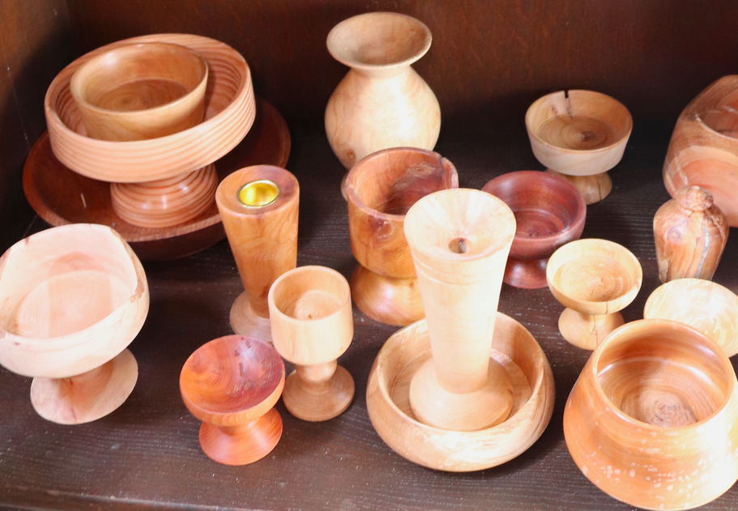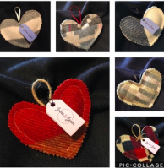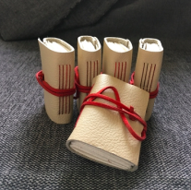
Some of the hand crafted items from our shop

St John’s House is a charity, our charity number is 1147340
Email: saintjohns@hotmail.co.uk
Website: https://stjohns-bridgend.org.uk
Facebook: St John’s House Bridgend
Address: 22 Newcastle Hill, Bridgend, CF31 4EY

