Newsletter – February 2023

St John’s House in February
We had a great January Open Day celebrating Sts Dwynwen and Valentine.
For our February Open Day we are decorating the house to celebrate St David’s Day so expect daffodils and flags and, of course, dragons. We’d love to see you there. We are also recommencing our Sunday openings from March to accommodate those who can’t make it on a Saturday. It will be the second Sunday of the month, same hours as a Saturday, 11am to 3pm.
Our next quiz in aid of St John’s will take place, as usual, at the outdoor bowls club in Newbridge Fields.

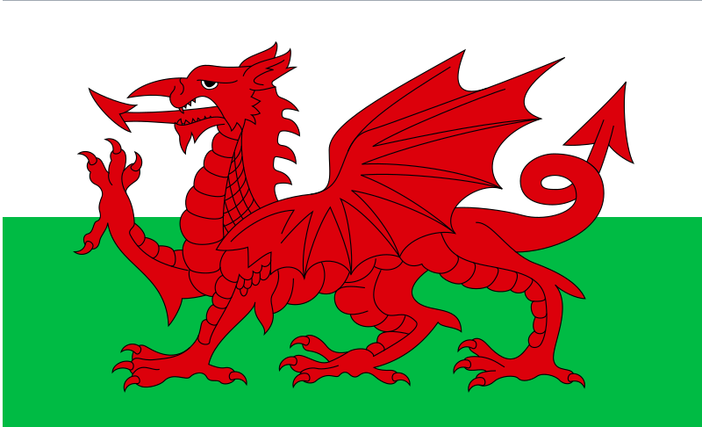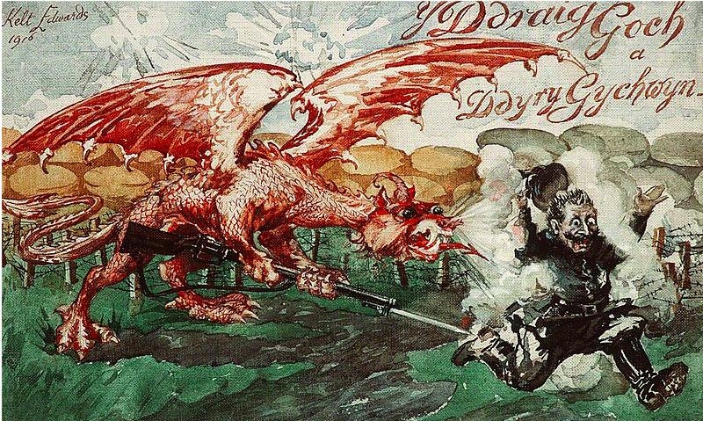

The use of the dragon as the symbol of Wales dates from the seventh century and the reign of Cadwallader, the King of Gwynedd. Henry Tudor, later Henry Vll^{th} was responsible for the three main features of the flag when he added the Green and White Tudor colours to the red dragon standard which he carried in his ultimately victorious battles against Richard lll^{rd}.
The motto, Y ddraig goch ddyry cychwyn or The red dragon will lead the way was added in 1953 taken from a poem by Deio ap Ieuan Du, a 15th century poet from Ceredigion. The 1916 painting, by John Keit Edwards, courtesy of the National Library of Wales, depicts the courage of the Welsh in WW1.

Dates for your diary

Next open days Saturday 25th February 2023 11am-3pm
Sunday 12th March 2023 11am-3pm
Saturday 25th March 2023 11am-3pm

Next two quiz dates Friday 17th February 2023 7.30pm
Friday 17th March 2023 7.30pm
St David’s Day

As with most saints, St David’ s details are sketchy and often confused. He was born in the late 5th century in Pembrokeshire, at the site of the chapel dedicated to his mother, St Non, reputedly in the midst of a great storm. What we know of his life was comes from the Buchedd Dewi or Life of David, written, originally in Latin, by Rhygyferch, the Bishop of St Davids in the late 11th century based, Rhygyferch maintained, on the cathedral records.
St David was revered as a great preacher, a modest and holy man who, again reputedly, lived on water, bread and herbs.
He performed a number of miracles, the most interesting of which was that, when preaching at the synod of Brefi, held in Llandewi Brefi, he was told that the people at the back couldn’t hear him so he caused the ground where he stood to raise up into a hill so that his voice could be heard and then a white dove settled on his shoulder. He was then elected Archbishop of Menevia, or Mynyw as St Davids was known before they renamed it after him.
He is recorded as having died on March 1st 589, a Tuesday, and was buried in Menevia/Mynyw/St Davids. He was canonized in 1120 and his Saints Day has been celebrated by the major Christian religions ever since. Before the reformation, two pilgrimages to St Davids were worth the same as one to Rome and three were worth the same as one to Jerusalem. If St John’s House was indeed a mediaeval hospice, a number of those pilgrims would have stayed at the house en route to St Davids.

Here at St John’s House we have all sorts of lovely items for sale, but, as it’s World Book Day on March 2nd, we’re focussing on our second hand books this month. We have a wide selection at only £1 each and, upstairs in the Solar,are books for children and we invite all of our younger visitors to help themselves to a free book from the selection in the Solar

St John’s House is a charity, our charity number is 1147340
Email: saintjohns@hotmail.co.uk
Website: https://stjohns-bridgend.org.uk
Facebook: St John’s House Bridgend
Address: 22 Newcastle Hill, Bridgend, CF31 4EY

