

**Newsletter** – August 2024

**St John’s House in August**

July saw lots of visitors here at St John’s House, both regular and new. We’ve put away the Acme Vacuum Flask Co. glassware and we’ve set up a new display in our exhibition space. This time it is maps of Bridgend. Thanks to our friends in the Bridgend & District Local History Society we have a number of different maps on show from a copy of the 1778 Dunraven map right through to those of the present day so pop along and see how Bridgend has changed and grown over the years.

In September we will be open three times to celebrate both Ogwr History Month and Cadw’s Open Doors. We have a few extra attractions, all free, to mark this. On Sunday September 8th you can meet our Victorian parlour maid who will talk about life in a Victorian household. On Saturday and Sunday 28th and 29th September we will be hosting the medieval archers who will demonstrate their equipment and talk about life as a bowman around the time St John’s House was built. We are grateful to the Awen Cultural Trust for their support in the history month’s activities.

The quiz in September is a week earlier than usual as the Outdoor Bowls Club are away on tour on our normail third Friday so it’s being held the week before.

In October Debra John is back with an evening of ghostly tales and, later in the year we are going to be running a series of candlelit tours of the house near Christmas and also some Christmas wreath-making workshops.

**Dates for your diary**

**Next open days** Sunday 11th August 2024 11am-3pm

Saturday 31st August 2024 11am-3pm

Sunday 8th September 2024 11am-3pm

Saturday 28th September 2024 11am-3pm

Sunday 29th September 2024 11am-3pm

**Next two quiz dates** Friday 16th August 2024 7.30pm

Friday 13th September 2024 7.30pm

**Wil Ifan – Archdruid**

We couldn’t let the National Eistefddfod, currently underway in Pontypridd, pass without a mention of our own Wil Ifan. He was Archdruid when the Eisteddfod came to Bridgend in 1948 and won the crown for pryddest (poetry in free verse) at three different Eisteddfodau. We have a bust of him here at St John’s House together with information on his life and a number of his books.

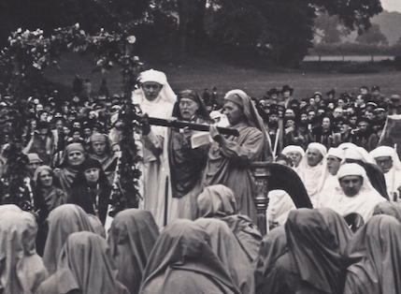

*The Gorsedd Circle in Newbridge Fields.*

*Wil Ifan (centre) in his robes as Archdruid at the Bridgend Eisteddfod in 1948*

Our shop has all sorts of traditional gifts and mementos of St John’s House including love spoons, postcards, cute small crocheted potted plants and our own range of stationery to remember us by. We also have an extensive seletion of secondhand books for sale so why not pop in and see what we have on offer.

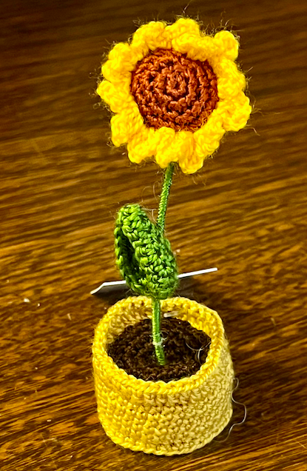 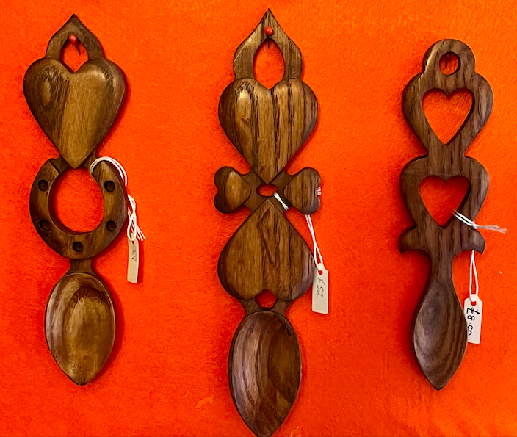 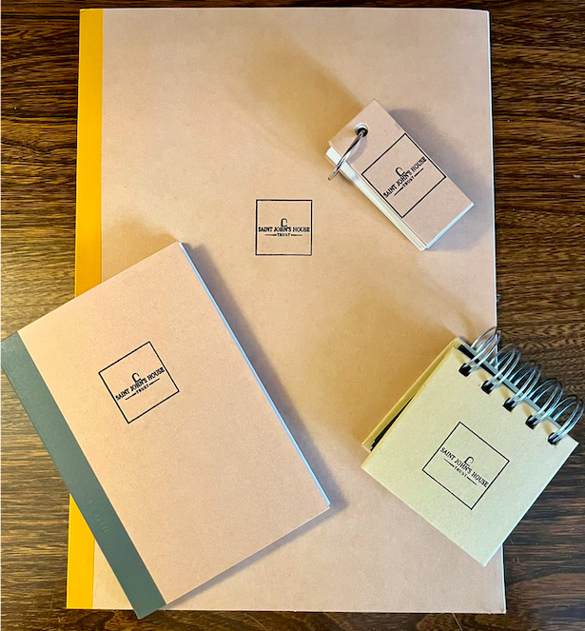

St John’s House is a charity, our charity number is 1147340

Email: [saintjohns@hotmail.co.uk](mailto:saintjohns@hotmail.co.uk)

Website: <https://stjohns-bridgend.org.uk>

Facebook: St John’s House Bridgend

Address: 22 Newcastle Hill, Bridgend, CF31 4EY