Newsletter – April 2023

St John’s House in April

Our Easter theme is still running for the Sunday 16th April Open Day so this will be your last chance to catch the Easter chick trail.
For the 25th April Open Day we are majoring on May Day and the Green Man so come along and see our Maypole and bring your children for the Green Man trail.
The April quiz in aid of St John’s will take place, as ever, at the outdoor bowls club in Newbridge Fields.
We have been busy planning events for later this year. We are hoping tp repeat the Hallowe’en story-telling evening in November and in December, we are intending to have an evening performance of recollections of Victorian Christmas so look out for details of these.
We are also planning a series of historical walks around Bridgend, starting at St John’s House and ending up back here for an after-walk cup of tea and Welsh cake.
To finish up we have also invited our good friends the folk musicians of the “Call of the Wild” group to come back and again fill the house with the kind of music our forebears would have enjoyed in this place.
It’s looking like a great year for St John’s, come along and share it with us!

Dates for your diary

Next open days Sunday 16th April 2023 11am-3pm
Saturday 29th April 2023 11am-3pm
Sunday 14th May 2023 11am-3pm
Saturday 27th May 2023 11am-3pm

Next two quiz dates Friday 21st April 2023 7.30pm
Friday 19th May 2023 7.30pm

May Day

May day harks back both to the Roman festival of Floralia, when they celebrated flowers, fertility and Spring in a somewhat raucous and bawdy festival dedicated to the Roman God Flora. It also has its roots in the Celtic festival of Beltane, a Gaelic fire festival with rituals of purification by fire, marking the end of winter and the coming of the sun.

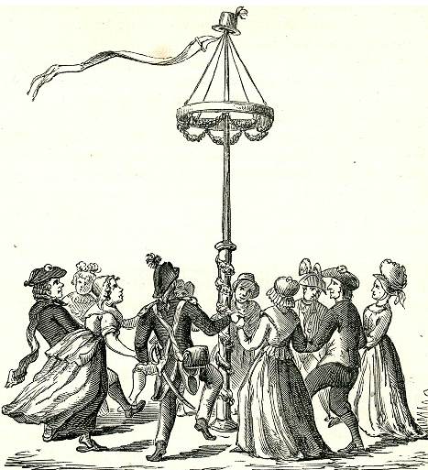
Here in Wales we, of course, have Calan Mai with its own set of customs and traditions. We have the maypole, strung with ribbons and celebrating fertility and the coming of summer, banned by the puritans for its “heathenish vanity” and restored under Charles ll. It has always been a joyous time with people enjoying the longer days, the fresh growth and the rebirth of nature after the cold of the winter. Indeed there used to be mock battles between those representing summer and winter. Needless to say, summer always won and the victory was celebrated with singing, dancing, bonfires, feasting and drinking. In some places, young men would tie bunches of the herb rosemary and leave them at the door of a young lady they fancied.

Calan Mai was also one of the times of the year when the spirit world and the real world were at their closest and witches were out to make mischief. There was a tradition of collecting hawthorn branches as a way of warding off these witches, though the hawthorn was considered unlucky and kept outside the house.

Here at St John’s House we are protected by our own witches’ marks so you will be perfectly safe with us!

Here at St John’s House we have all sorts of lovely items for sale.
Have a look in our shop and see what you can find
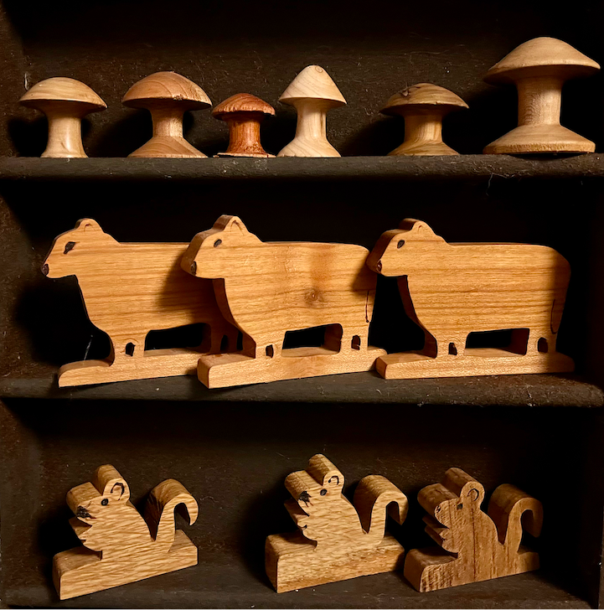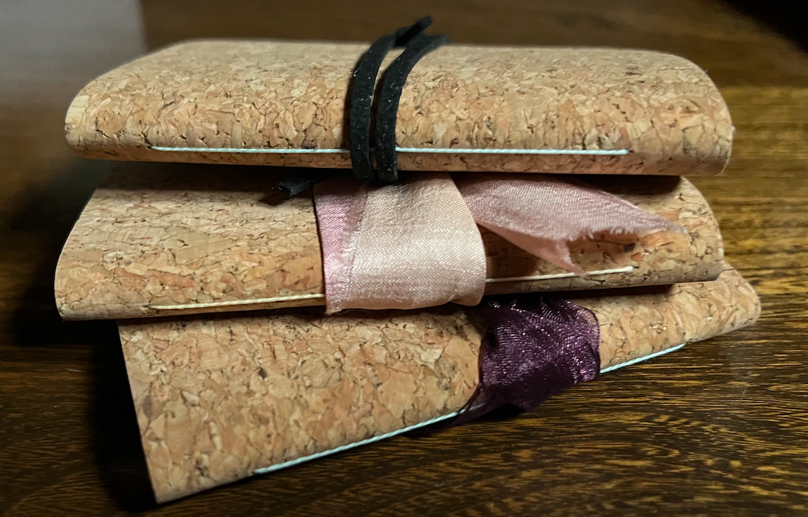
St John’s House is a charity, our charity number is 1147340
Email: saintjohns@hotmail.co.uk
Website: https://stjohns-bridgend.org.uk
Facebook: St John’s House Bridgend
Address: 22 Newcastle Hill, Bridgend, CF31 4EY

